EASEMYTRIP PROJECT

Functional Requirements Specification

|  |  |  |  |
| --- | --- | --- | --- |
|  | Prepared By | Reviewed By | Approved By |
| Name | Assert Ninjas | Devathilagai |  |
| Role | GenC Interns | Batch Trainer |  |

**Table of Contents**

Table of Contents…………………………………………………………..….......II

1. Introduction…………………………………………………………………..…1

1.1 Intended Audience……………………………………………….......1

1.2 Project Scope…………………………...……………………………1

2. Overall Description…………………………………………….……………….1

2.1 Operating Environment……………………...……………………....1

3. Requirements……………………………………………………………...…….1

3.1Login………………………………………………………………….2

3.1.1Description………………………………………………....2

3.1.2 Functional Requirements……..…………………………...2

**1. Introduction**

EaseMyTrip is an online travel booking website. We are taking and testing 6 functionality of that website (i.e.) Searching for Cabs, Activities, Hotels and GiftCards.

**1.1 Intended Audience**

Business Unit (BU) SME

Academy coach

Technical Trainer

**1.2 Project Scope**

This document defines at a functional level the business activities that are encompassed by the system and the rules that apply to them. It also encompasses some of the key high and low-level technical requirements of the system.

It draws heavily on both proposed Framework and Business Rules and the Technical Architecture documents.

The scope of the detailed analysis project phase specifies that this document will include.

· Classification of requirements according to their functional areas.

· A description of each process in the system, including their inputs, outputs, and data transformation rules.

**2. Overall Description**

**2.1 Operating Environment**

Windows operating system

Web application

**3. Requirements**

This part of the requirements document serves to present the "EaseMyTrip for travel booking" of the application and also we need to extract all the levels in “Web Application”.

**3.1.1 Functional Requirements**

**3.1.1.1 Req0001**

**Req0001a-** The user clicks on Cabs Tab, then selects “Airport Transfer”

**Req0001b**- The user enters the text as “coimbatore” in From textbox and selects “ Coimbatore International Airport” from the auto suggestion list box.

**Req0001c**- The user enters the text as “munnar” in To textbox and selects   
“ munnar” from the auto suggestion list box.

**Req0001d**- The user selects pickup date from calendar and selects time from dropdown.

**Req0001e-** The user clicks “Search” button, then the webpage will show the results of cab names and prices.

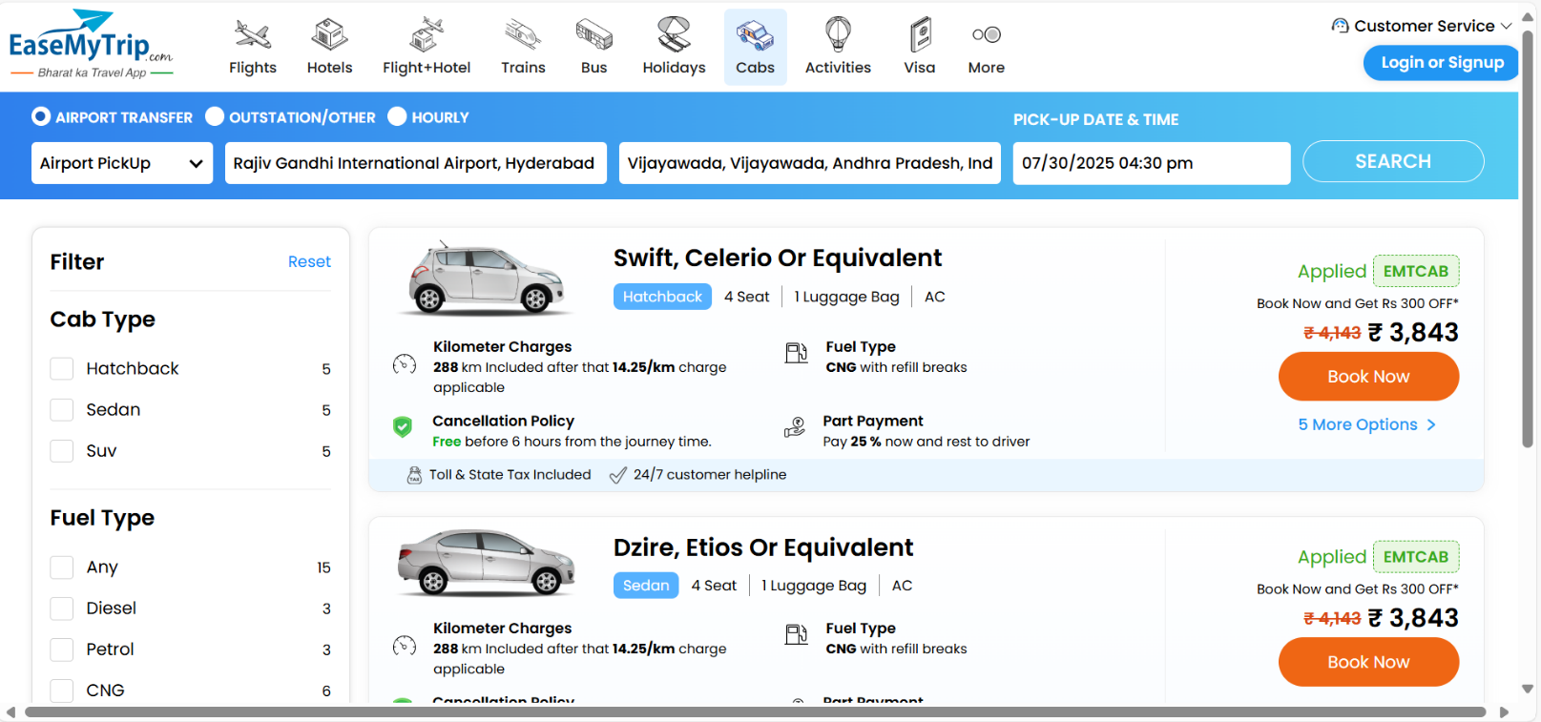

**3.1.1.2 Req0002**

**Req0002a-** The user clicks on Cabs Tab, then selects “Airport Transfer” in that select “Airport Drop” from dropdown.

**Req0002b**- The user enters the text as “munnar” in From textbox and selects   
“ munnar” from the auto suggestion list box.

**Req0002c**- The user enters the text as “coimbatore” in To textbox and selects   
“ Coimbatore International Airport” from the auto suggestion list box.

**Req0002d**- The user selects pickup date from calendar and selects time from dropdown.

**Req0002e-** The user clicks “Search” button, then the webpage will show the results of cab names and prices.

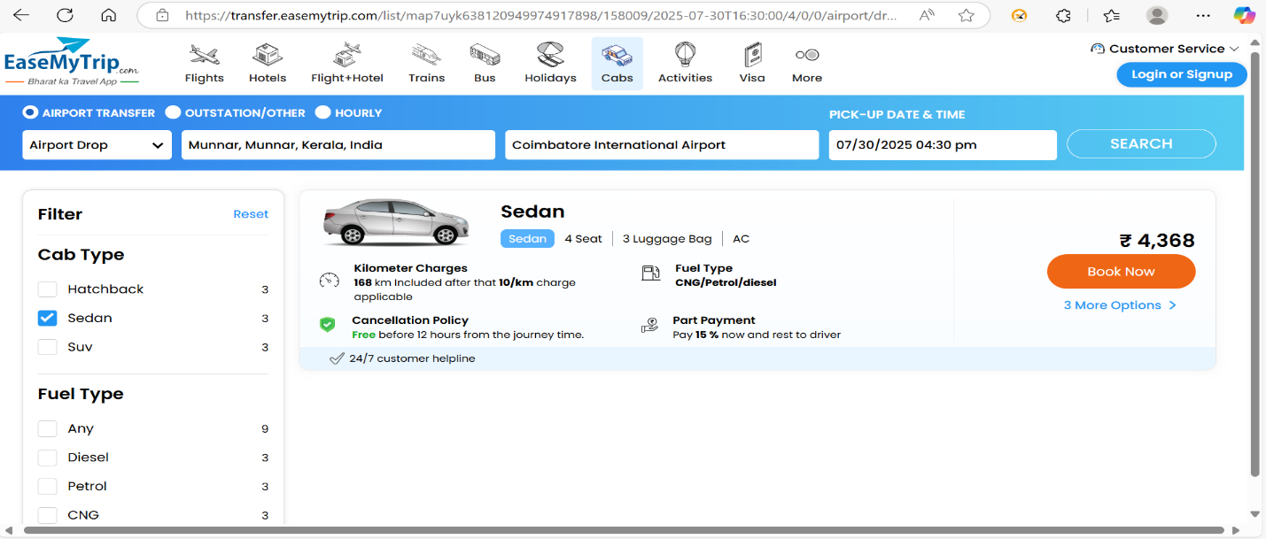

**3.1.1.3 Req0003**

**Req0003a-** The user clicks on Cabs Tab, then selects “Hourly”.

**Req0003b**- The user enters the text as “munnar” in From textbox and selects   
“ munnar” from the auto suggestion list box.

**Req0003c**- The user selects pickup date from calendar and selects time from dropdown.

**Req0003d**- The user selects “Rent for” hours from dropdown.

**Req0003e-** The user clicks “Search” button, then the webpage will show the results of cab names and prices.

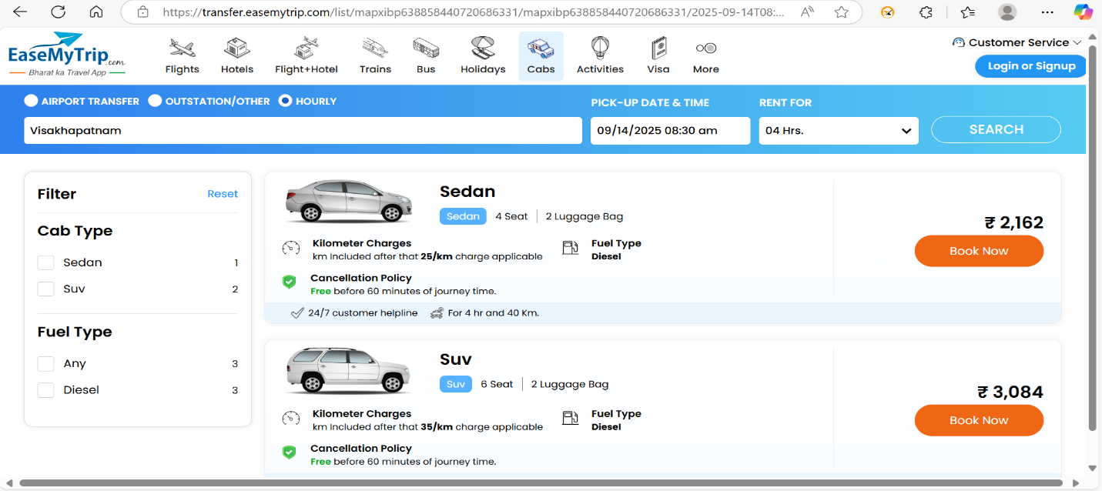

**3.1.1.4 Req0004**

**Req0004a-** The user clicks on Cabs Tab, then selects “Outstation”.

**Req0004b**- The user enters the text as “munnar” in From textbox and selects   
“ munnar” from the auto suggestion list box.

**Req0004c**- The user enters the text as “munnar” in To textbox and selects   
“ munnar” from the auto suggestion list box.

**Req0004d**- The user selects pickup date from calendar and selects time from dropdown.

**Req0004e-** The user clicks “Search” button, then the webpage will show the results of cab names and prices.

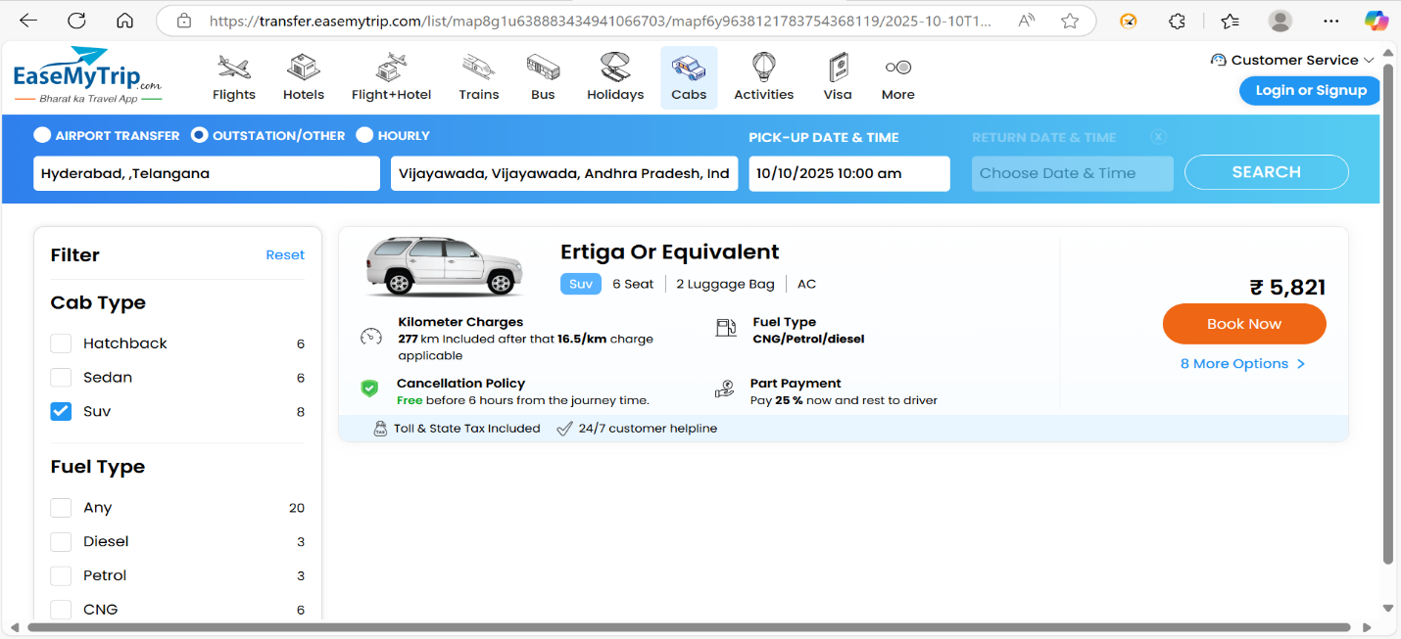

**3.1.1.5 Req0005**

**Req0005a-** The user clicks on Cabs Tab, then selects “Outstation”.

**Req0005b**- The user enters the text as “munnar” in From textbox and selects   
“ munnar” from the auto suggestion list box.

**Req0005c**- The user enters the text as “munnar” in To textbox and selects   
“ munnar” from the auto suggestion list box.

**Req0005d**- The user selects pickup date from calendar and selects time from dropdown.

**Req0005e-** The user clicks the round trip, then selects return date from calendar and selects time from dropdown.

**Req0005f-** The user clicks “Search” button, then the webpage will show the results of cab names and prices.

**3.1.1.6 Req0006**

**Req0006a-** The user clicks on “Activities Tab”.

**Req0006b**- The user enters the text as “Ba” in Where textbox.

**Req0006c**- The user selects month, year and date from calendar.

**Req0006d-** The user clicks “Search” button, then it will display the Error Message.

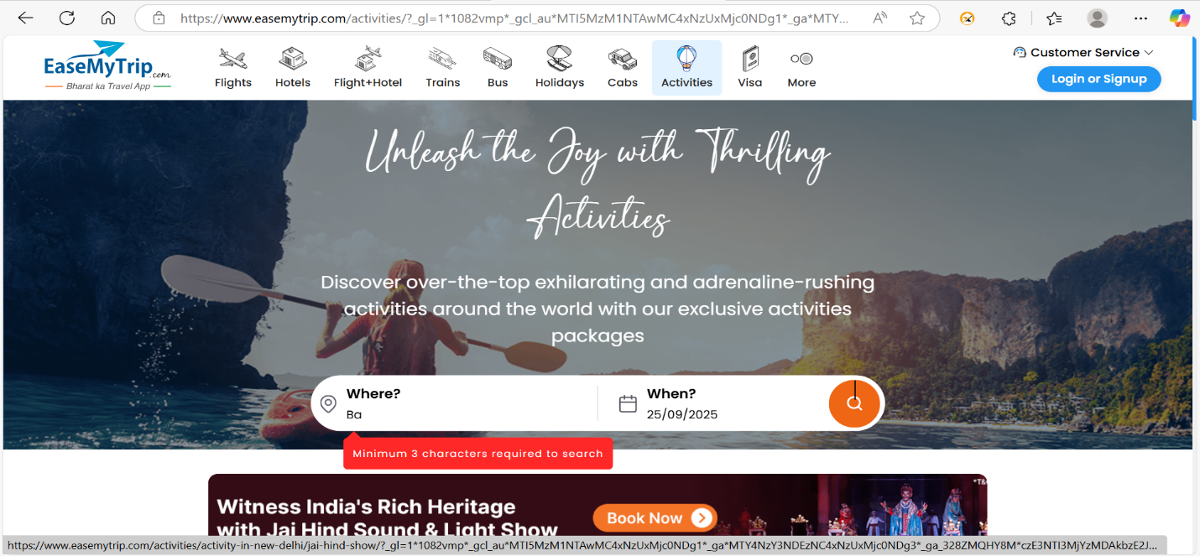

**3.1.1.7 Req0007**

**Req0007a-** The user clicks on “Activities Tab”.

**Req0007b**- The user enters the text as “Delhi” in From textbox and selects   
“New Delhi” from the auto suggestion list box.

**Req0007c**- The user selects month, year and date from calendar.

**Req0007d-** The user clicks “Search” button, then the webpage will show the results.

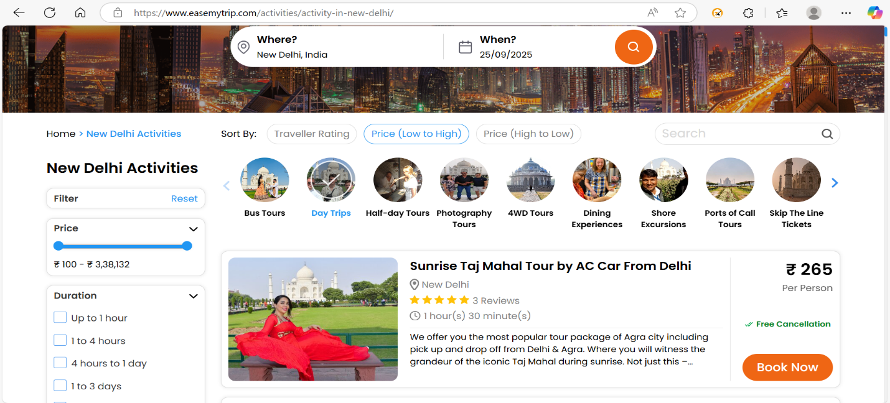

**3.1.1.8 Req0008**

**Req0008a-** The user clicks on “Hotels Tab”.

**Req0008b**- The user enters the text as “Delhi” as city name in textbox and selects   
“Dwarka” from the auto suggestion list box.

**Req0008c**- The user selects Check-In date from calendar.

**Req0008d-** The user selects Check-Out date from calendar and Rooms & Guests from dropdown and click “Done” button.

**Req0008e-** The user clicks “Search” button, then the webpage will show the results of Hotel names and prices.

**3.1.1.9 Req0009**

**Req0009a**- The user Mouse over to “More Tab”, then selects “GiftCard”.

**Req0009b-** The user mouse over to “Festival” and clicks on festival.

**Req0009c-** The user selects “Diwali”, then scroll to fill form.

**Req0009d-** The user fills the necessary data until sender’s name.

**Req0009e-** Then the invalid email and valid mobile number.

**Req009f-** Then user clicks on “I accept the terms and conditions” checkbox, then it will show the Error Message and takes Screenshot where Error Message shown.

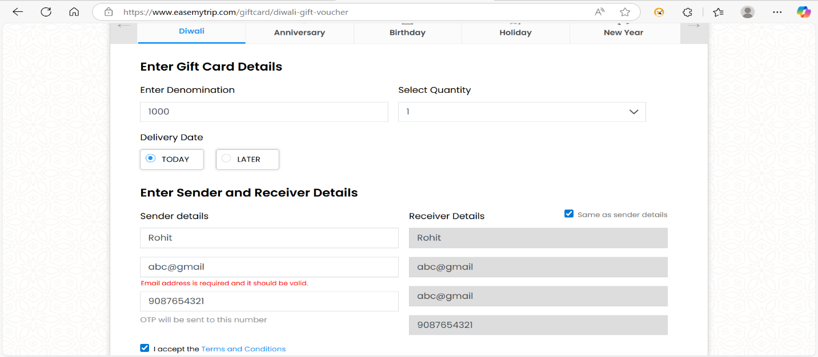

**3.1.1.10 Req0010**

**Req0010a**- The user Mouse over to “More Tab”, then selects “GiftCard”.

**Req0010b-** The user mouse over to “Festival” and clicks on festival.

**Req0010c-** The user selects “Diwali”, then scroll to fill form.

**Req0010d-** The user fills the necessary data until sender’s name.

**Req0010e-** Then the valid email and invalid mobile number.

**Req0010f-** Then user clicks on “I accept the terms and conditions” checkbox, then it will show the Error Message and takes Screenshot where Error Message shown.

